
TRIBHUVAN UNIVERSITY
INSTITUTE OF ENGINEERING
PULCHOWK CAMPUS

Mid-term Report
On
‘CORVID’ – Intelligent Email Processor

Submitted By

Lekhnath Bhusal (060BCT515)
Madhav Sigdel (060BCT516)
Mahesh Raj Regmee (060BCT517)
Prajwal Shrestha (060BCT528)

December 2007
TRIBHUVAN UNIVERSITY
INSTITUTE OF ENGINEERING
PULCHOWK CAMPUS

Mid-term Report
On
‘CORVID’ – Intelligent Email Processor

Submitted By

Lekhnath Bhusal (060BCT515)
Madhav Sigdel (060BCT516)
Mahesh Raj Regmee (060BCT517)
Prajwal Shrestha (060BCT528)

SUBMITTED TO THE
DEPARTMENT OF ELECTRONICS AND COMPUTER ENGINEERING IN PARTIAL FULFILLMENT OF THE REQUIREMENT FOR BACHELOR’S DEGREE IN COMPUTER ENGINEERING
December 2007

Acknowledgement

Secret behind every successful project is proper planning, sufficient preliminary studies and smart implementation of planned activities. Continuous help from various persons was vital in achieving the goals to come up with solid project outcomes. In this regard, the authors would like to express their vote of thanks to following people/organizational unit.

- Department of Electronics and Computer Engineering.
- Project Supervisors Er. Jayaram Timsina and Er. Ram Govinda Aryal for the support and encouragement in proceeding with the project.
- Shankar Raj Uprety, Senior Engineering manager, D2Hawkeye Services and Subash Devkota, Software Engineer D2Hawkeye Services, Bishalnagar for their helpful suggestion and supervision.
- D2Hawkeye Services, Bishalnagar for its guidelines and support for the project.
- Our seniors for their valuable materials and suggestions.
- Our friends and family for their direct or indirect support in project study.

Lekhnath Bhusal
Madhav Sigdel
Mahesh Raj Regmee
Prajwal Shrestha

Abstract
Email satisfies the basic human need for communication and has become mission critical in every organization. Billions of emails are delivered each day connecting people around the globe. Unfortunately, majority of these emails are unsolicited bulk emails or spam. Automatic filtering of such mails has become a must. Classification of emails into different categories makes the email management easy. Also it is difficult to extract important information from sequence of mail replies or a long mail. A good summarization tool can spare user from this tedious task. If learning can be incorporated into email clients by tracking user’s actions to emails, we can automate such tasks and help the user in managing his inbox.
CORVID is a solution to these problems. It is a module that adds intelligence to email client for filtering, classification and summarization of emails. CORVID initially consists of knowledge base and it is updated continuously so that the user’s inbox is personalized. The project is developed for the partial fulfillment of requirement for Bachelor’s in Computer Engineering and is done in co-operation with D2Hawkeye Services, Bishalnagar.

Keywords: Mozilla, XPCOM Component, Naïve Bayesian, Associative Rule, Machine Learning

Table of Contents

Acknowledgement i
Abstract ii
1 Introduction 1
1.1 Background 1
1.2 Problem Statement 1
1.3 Objectives 2
1.4 Scope 2
2 Literature Review 3
2.1 General 3
2.1.1 Email 3
2.1.2 E-mail spam 3
2.1.3 Mail Server 3
2.1.4 Email Client 4
2.2 Mozilla Applications 4
2.2.1 Mozilla Foundation 4
2.2.2 Mozilla Thunderbird 4
2.2.3 Mozilla Architecture 4
2.3 Extension to Mozilla Applications 5
2.3.1 Extension Architecture 6
2.3.2 XUL 6
2.3.3 Overlays 7
2.3.4 JavaScript 7
2.3.5 XPCOM and XPConnect 7
2.3.6 XPInstall 8
2.4 Algorithms 9
2.4.1 Naïve Bayes classifier 9
2.4.2 Associative rules classifier 9
2.4.3 Machine Learning 9
2.4.4 Email Structure 10
3 Feasibility Analysis 10
3.1 Operational Feasibility 10
3.2 Technical Feasibility 10
3.3 Economic Feasibility 11
3.4 Schedule Feasibility 11
3.5 Risk Analysis 11
4 System Analysis 12
4.1 Overview 12
4.2 System Architecture 12
4.3 Context Level DFD 13
4.4 Use Case Diagram 14
5 System Design 15
5.1 Email Classification 15
5.1.1 Classification Design Framework 15
5.1.2 Data Processing 16
5.1.3 Classifier Building 18
5.1.4 Classifier Testing 19
5.2 Email Filtration 19
5.2.1 Filter Design Framework 19
5.2.2 Data Processing 20
5.2.3 Filter Model 20
5.2.4 Testing filter 21
5.3 Email Summarization 21
5.3.1 Email Preprocessing 22
5.3.2 Noun Phrase Extraction and Filtering 22
5.3.3 Machine Learning Unit 22
5.3.4 Presentation 22
6 System Development 23
6.1 Methodology 23
6.2 Tools & Environment 23
6.2.1 Visual Studio 2005 23
6.2.2 Gecko SDK 23
7 Project Status 24
7.1 Completed Tasks 24
7.2 Remaining Tasks 24
8 Concluding Words 25
9 References 26
10 Appendices 27

List of Figures

Figure 1: Mozilla Extension Architecture 6
Figure 2: System Architecture of CORVID 12
Figure 3: Context Level DFD of CORVID 13
Figure 4: CORVID Use Case Diagram 14
Figure 5: Email Classification Process 15
Figure 6: Message Parsing & Presentation (Pre-processing) 16
Figure 7: Email Filtration Process 19
Figure 8: Email Summarization Process 21
Figure 10: Overall Project Status 24
Figure 11: Snapshot showing CORVID email filtering in Thunderbird 27
Figure 12: Snapshot showing CORVID features 27

1 Introduction

Background
Email (Electronic Mail) is one of the most important applications used to communicate over the Internet. It is a push-only medium. The control of who is receiving which information is mainly with the sender. Hence this leads to an overflow of unwanted information in receiver’s inbox. Even the necessary emails are in large number and it is difficult to identify important information from a sequence of emails. Email service is provided in different mechanisms such as web-based or mail client. Web based mail service can be accessed from anywhere through the internet however they only provide generic services and require internet accessibility. User specific services are not directly available in the servers. For such services and offline email achieving email client is required.
There have been different research in the field of Email filtering and different algorithms have been devised. Bayesian classification has been the mostly used one. Different mail service providers provide anti-spam techniques. Web mail providers such as Gmail, Yahoo have applied static mail filtering algorithms and appropriate actions such as deleting the mail, moving a folder etc. can be defined. Mail clients like Mozilla Thunderbird and Microsoft Outlook Express have made filtering techniques very robust. Mailwasher Pro has also incorporated Bayesian learning for spam mail detection. POPFile is another similar application which sorts mail in different categories such as (family, friends, co-worker, spam etc.) with Bayesian filtering.

Problem Statement
Most of the existing applications found so far use static filters and hence do not address changing requirement of users. Likewise, some use Naïve Bayesian for classification which considers single words as features and spammers have already devised techniques to override such filters. Also summarization feature is not present which can help in extracting important sentences from a long email.

Objectives
We propose to develop a system that can learn user preferences for filtering and categorization of email from user activities pertaining to an email message. Along with this, it is required to generate relevant summary of email threads. To achieve this, we have set the following objectives:
- Develop a module for email filtering
- Develop email classification module
- Develop email summarization module
- Integrate the above modules as an extension to Mozilla Thunderbird

Scope

The project CORVID has been undertaken to fulfill the requirement of Major Project for Bachelor’s Degree in Computer Engineering and has to be completed within the end of final semester.
Mozilla Thunderbird users can use CORVID for managing their inbox through personalization. They can use the CORVID’s feature such as spam/ ham detection of an email, classification of incoming emails to folders and to extract important parts as summary of an email. Besides, the modules can be run independently to find the spam/ham prediction, folder category of an email or to extract summary. The summarization module can also be used to summarize documents.

Literature Review

General

Email
E-mail, short for electronic mail, is a store and forward method of composing, sending, storing and receiving messages over electronic communication systems. It is often abbreviated to e-mail or simply mail. The term e-mail as a noun or verb applies both to the Internet e-mail system based on the Simple Mail Transfer Protocol (SMTP), X.400 systems and to intranet systems allowing users within one organization to e-mail each other. Often these workgroup collaboration organizations may use the Internet protocols or X.400 protocols for internal e-mail service.

E-mail spam
E-mail is often used to deliver bulk unsolicited messages known as spam, bulk or junk e-mails. It is a subset of spam that involves sending nearly identical messages to numerous recipients by e-mail. A common synonym for spam is unsolicited bulk e-mail (UBE). Some definitions of spam specifically include the aspects of email that is unsolicited and sent in bulk. The spam emails mainly contain commercial, financial, or other leisure advertisements. Filter programs exist to detect whether an email is spam or not, which can automatically delete some or most of these, depending on the situation.

Mail Server
A mail server or a mail exchanger (in the context of the Domain Name System) is a computer program or software agent that transfers electronic mail messages from one computer to another. It receives messages from another MTA (mail transfer agent) (relaying), a mail submission agent (MSA) that itself got the mail from a mail user agent (MUA), or directly from an MUA, thus acting as an MSA itself. The delivery of e-mail to a user's mailbox takes place via mail delivery agent (MDA).

Email Client
An e-mail client is a front end computer program used to manage e-mail. Mozilla Thunderbird, Outlook Express, Evolution Mail are some of the popular email clients. Email Clients use POP3 or IMAP to retrieve messages and use SMTP to send messages. Fewer Internet Service Providers (ISPs) support IMAP.

Mozilla Applications

Mozilla Foundation
The Mozilla Foundation is a non-profit organization that exists to support and provide leadership for the open source Mozilla project. The organization sets the policies that govern development, operates key infrastructure and controls trademarks and other intellectual property. It owns a taxable subsidiary called the Mozilla Corporation, which employs several Mozilla developers and coordinates releases of the Mozilla Firefox web browser and the Mozilla Thunderbird email client.

Mozilla Thunderbird
Mozilla Thunderbird is a free, open source, cross-platform e-mail and news client developed by the Mozilla Foundation. The project strategy is modeled after Mozilla Firefox, a project aimed at creating a web browser. Thunderbird aims to be simple, safe and easy to use email client. It can manage multiple e-mail, newsgroup and RSS accounts and supports multiple identities within accounts. It has features such as intelligent spam filters, quick message search, and customizable views. Thunderbird incorporates a Bayesian spam filter, a white list based on the included address book, and can also understand classifications by server-based filters such as SpamAssassin. Its pluggable interface lets developers freely build extensions to make it ever more useful

Mozilla Architecture
The biggest advantage Mozilla has for a developer is that Mozilla-based applications are cross-platform, which means that these programs work the same on Windows as they do on Unix or the Mac OS. It's possible to have applications run across different platforms because Mozilla acts as an interpretation layer between the operating system and the application. As long as Mozilla runs on a given computer, most Mozilla-based applications also run on that computer, regardless of what operating system it uses. XPFE, Mozilla's cross-platform front end, was designed to solve this problem by enabling engineers to create one interface that would work on any operating system. a front end is more than the look and feel of an application, since it also includes the functionality and structure of that application. XPFE uses a number of existing web standards, such as Cascading Style Sheets, JavaScript, and XML (the XML component is a new language called XUL, the XML-based User-interface Language). In its most simple form, XPFE can be thought of as the union of each technology. JavaScript creates the functionality for a Mozilla-based application, Cascading Style Sheets format the look and feel, and XUL creates the application's structure. Instead of using platform-specific code in languages like C or C++ to create an application, XPFE uses well-understood web standards that are platform-independent by design. Because the framework of XPFE is platform-independent, so are the applications created with it.

Extension to Mozilla Applications
Extensions add new functionality to Mozilla applications such as Firefox and Thunderbird. They can add anything from a toolbar button to a completely new feature. They allow the application to be customized to fit the personal needs of each user if they need additional features, while keeping the applications small to download. It is the most convenient way to distribute and add new customized feature to the existing application.

Some Popular Firefox Extensions are:
- ForecastFox
- ChatZilla
- Adblock Plus
Some Popular Thunderbird Extensions are:
- Enigmail
- FoxyTunes

Extension Architecture
The general architecture of creating extensions is as shown below. The extension is generally packaged as xpi or zippy file that manages the transfer and registry of all components -- the chrome files in the JARs, the executables, the default user information, and the libraries. It contains the XUL files, overlays, event handlers in JavaScript, XPCOM components and XPCOM interface in between.
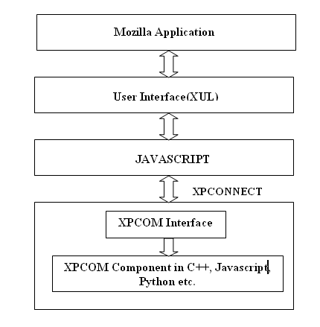
Figure 1: Mozilla Extension Architecture

XUL
XUL (pronounced "zool") is Mozilla's XML-based user interface language that allows building feature rich cross-platform applications that can run connected to or disconnected from the Internet. These applications are easily customized with alternative text, graphics, and layout so they can be readily branded or localized for various markets. Web developers already familiar with Dynamic HTML (DHTML) will learn XUL quickly and can start building applications right away.
- Powerful widget-based markup language - artifacts such as windows, labels and buttons instead of pages, heading levels, and hypertext links.
- Based on existing standards - XUL is an XML language based on W3C standard XML 1.0
- Platform portability - XUL designed to be platform-neutral, it delivers on the promise of write-once, run-anywhere.
- Separation of presentation from application logic
- Easy customization, localization, or branding

Overlays
An overlay is a separate file in which additional XUL content can be defined and loaded at runtime. Overlays are often used to define things like menus that appear in different components or parts of the application. If you are creating a large application or a UI with many elements as a part of your design, the files can easily become large. The size in itself does not render it ineffective, but it does make the job of the developer a little difficult when tracking down and changing features. The best way to overcome this size problem is to use overlays. Another reason to use overlays is to extract information from a certain logical portion of the UI and contain it in a file of its own. This extraction and containment promotes modularization and reusability.

JavaScript
JavaScript is a small, lightweight, object-oriented, cross-platform scripting language. It adds the functionality to Mozilla applications. This is the main language for event handling in Mozilla applications. We can also create XPCOM Components in Javascript.

XPCOM and XPConnect
XPCOM and XPConnect are complementary technologies that enable the integration of external libraries with XUL applications. XPCOM, which stands for Cross Platform Component Object Model, is a framework for writing cross-platform, modular software. XPCOM components can be written in C, C++, and JavaScript, and they can be used from C, C++, JavaScript, Python, Java, and Perl. XPCOM itself provides a set of core components and classes, e.g. file and memory management, threads, basic data structures (strings, arrays, and variants), etc. In other words, XPCOM is used to allow JavaScript, or potentially any other scripting language, to access and utilize C and C++ libraries.
XPConnect is a technology which enables simple interoperation between XPCOM and JavaScript. XPConnect allows JavaScript objects to transparently access and manipulate XPCOM objects. It also enables JavaScript objects to present XPCOM compliant interfaces to be called by XPCOM objects. Together, XPCOM and XPConnect enable developers to create XUL applications that require the raw processing power of compiled languages (C/C++) or access to the underlying operating system.

XPInstall
XPInstall, Mozilla's Cross Platform Install facility, provides a standard way of packaging XUL application components with an install script that Mozilla can download and execute. XPInstall enables users to effortlessly install new XUL. Extensions are in a form of installable bundle which can be downloaded and installed by a user, or provided pre-packaged with an application or by an external program. Extensions use a directory structure which can provide chrome, components, and other files to extend the functionality of a XUL program. Every extension must provide an install.rdf file which contains metadata about the extension, such as its unique ID, version, author, and compatibility information. After the extension files and install.rdf have been prepared, there are several ways to prepare an extension for installation: ZIP the extension directory into a user-installable XPI (xpinstall) file, unpack the extension directly into the user's application or profile directory, or register the extension in the Windows registry.

2.4 Algorithms

2.4.1 Naïve Bayes classifier
Naive Bayes classifier is a simple probabilistic classifier based on applying Bayes' theorem with strong (naive) independence assumptions. A more descriptive term for the underlying probability model would be independent feature model” (Wikipedia).
”Bayes classifiers are probabilistic in nature, i.e. they not only perform a classification but also predict a degree of confidence in the class assigned. The probability of a document d_{i} to belong to topic C_{j} is calculated using Bayes rule as follows:
p (C_{j} /d_{i}) = [ p (d_{i}/ C_{j})* p (C_{j}) ] / p (d_{i})
The classification result can be either a single topic with maximum predicted probability or the complete probability distribution.

2.4.2 Associative rules classifier
Associative classification is a combination of two data mining problems, association and classification, that uses association rules to predict a class label. It is based on the suggestion that several documents containing the same frequent term association belong to the same class. The method is gaining popularity due to several reasons. First, the classifier can handle feature spaces of tens of thousands dimensions, while decision tree classifiers are limited to several hundreds attributes only. Second, the classifier is able to consider terms together as a group, which relaxes the independence assumption methods like Naive Bayes are based on.

2.4.3 Machine Learning
Machine learning is concerned with the design and development of algorithms and techniques that allow computers to learn. At a general level, there are two types of learning: inductive, and deductive. Inductive machine learning methods extract rules and patterns out of massive data sets. Deductive learning proceeds from general principles or premises to derive particular information. The basic difference between the two can be summarized in the deductive dynamic of logically progressing from general evidence to a particular truth or conclusion; whereas with induction the logical dynamic is precisely the reverse. Inductive reasoning starts with a particular observation that is believed to be a demonstrative model for a truth or principal that is assumed to apply generally.

Email Structure
A mail message consists of a header, which contains information about who the message was sent from, the recipient(s) and the route. Many of the header fields are not shown by default, but most programs used to read email will allow full headers to be displayed. This is then followed by the body of the message which contains whatever the sender wishes. lf the mail message is a formal one, it is customary although not obligatory to finish with your name, return address and other useful information as a signature. In the context of extracting important parts from an email text, generally the important parts are contained in the subject and body part of the message. Hence for good summarization, other headers and signature parts need not be considered.

Feasibility Analysis

Operational Feasibility
Mozilla Thunderbird is a popular mail client and CORVID is an extension to it with added intelligence in filtering, email classification and support for email summarization. Since, this functionality can be easily incorporated in the existing system the project will definitely be useful to the users. Users will benefit from the intelligence added to Thunderbird. The confidence of CORVID system will go on increasing as it is used and can suggest things intelligently. The confidence level will be less in the early usage of the system.

Technical Feasibility
CORVID is an extension to Thunderbird; therefore we require good knowledge of the design and implementation of it. Thunderbird is open source and its documentation is readily available. Also we can get support from the forums of Thunderbird. Besides we are building the project in co-operation with D2hawkeye Services, Bishalnagar from where we obtain good support and supervision from our mentors. The help of supervisors, access to information in the internet and different books, research papers and articles will suffice.

Economic Feasibility
The development of CORVID requires Mozilla Thunderbird source code which is open source and GPL licensed. The tools required for the development and extension of Thunderbird is also easily available, therefore there is no cost for the tools. Further the project is an academic project. Therefore costs of manpower are not involved. This makes the project economically feasible.

Schedule Feasibility
The time period of 4 months is a short time for this project which requires extensive research and experiments. But the target is to provide basic functionalities and develop it as an extension to Mozilla Thunderbird. Thus basic requirements can be fulfilled within the time frame.

Risk Analysis
CORVID is a project incorporating Artificial Intelligence and hence requires extensive research. We are a group of four members and have time limit of around 4 months which is very less for this sort of project. However, different algorithms have been devised for email filtering and email classification. Due to time constraint, we will study and implement these algorithms instead of developing new algorithms and build a basic framework for developing such system. Hence implementation of these algorithms may possess some risk in performance level. But the application can be developed within the time frame.

System Analysis

Overview
CORVID is an intelligence extension to email clients and specifically to Mozilla Thunderbird. It adds the functionality of Email filtering and classification through learning of users actions to emails and also provides the facility of extraction of important information from long sequence of email replies. It applies statistical classification techniques. It uses machine linguistic and learning technique for summarization.

System Architecture
CORVID consists of 3 independently functioning modules for email filtration, email classification and email summarization. These modules use Knowledge base which will be created during training of the modules during development. The knowledge base will be updated through personalization. These modules will be integrated into Mozilla Thunderbird from where each feature can be used for user email in Thunderbird. Email filtration, classification and summarization modules are developed
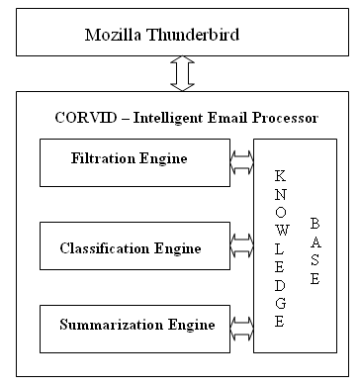
Figure 2: System Architecture of CORVID

in C++. XPCOM Component of the engines is called from Javascript. User Interface is added in Mozilla Thunderbird using overlays in XUL.

Context Level DFD
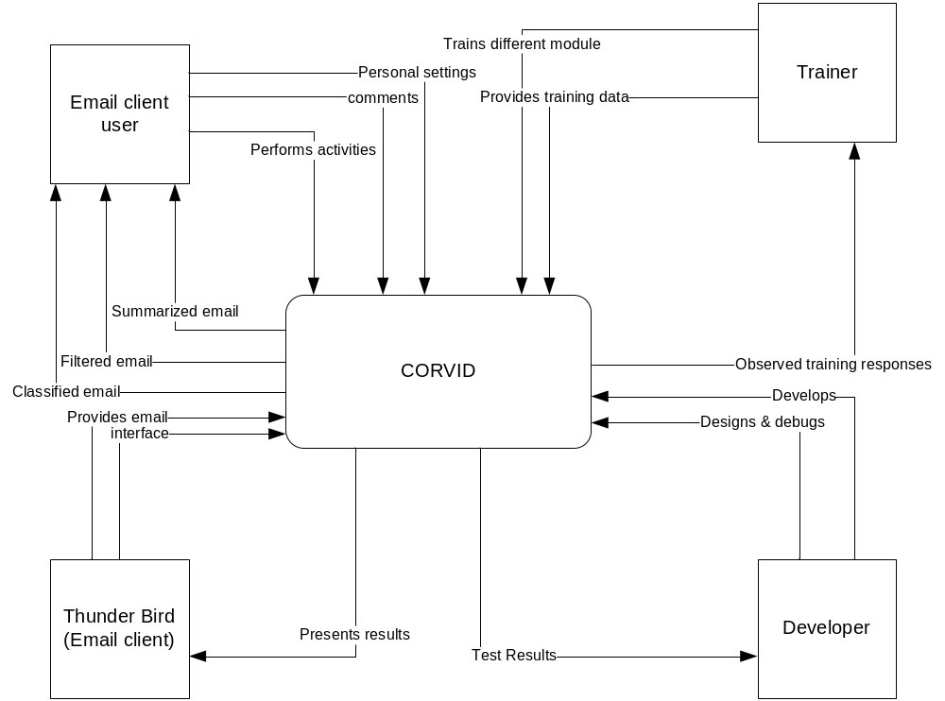

Figure 3: Context Level DFD of CORVID

Use Case Diagram
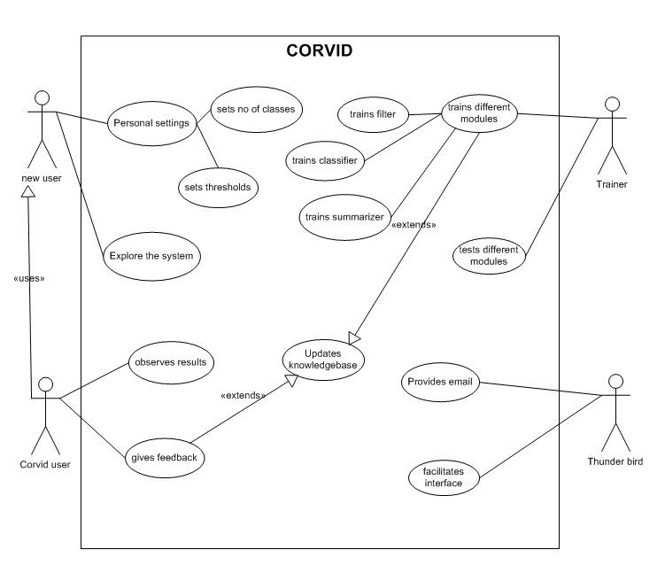

Figure 4: CORVID Use Case Diagram

- System Design

Email Classification

Classification Design Framework

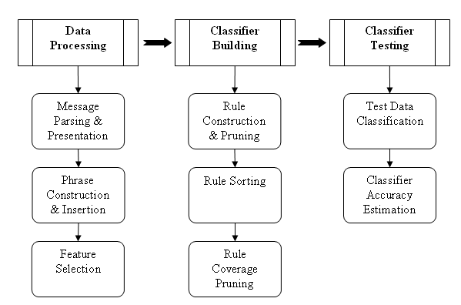

Figure 5: Email Classification Process

Input to classification module is an email message and output from it is a probability
distribution of classification suggestion for the message. The classification process goes as follows:
- Develop a model for classification using training set of emails
- Test that model with a different set of emails
- Once the model is developed use that model to classify the incoming emails.

The output of the above block diagram is classifier model in the form of a set of rules. Each rule is in the form: pattern→class c, with probability p. Now, a collection of pattern in incoming email gives probability distribution of classes pertaining to that email.

Data Processing
This module processes the incoming emails and presents a set of patterns, representing the message, to the classifier building module. The patterns are in the form of set of vectors of integers. Each integer represents a word, stemmed to its root form, found in the message. Components of this module are:

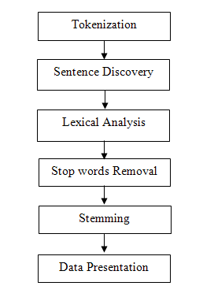
Figure 6: Message Parsing & Presentation (Pre-processing)

- Message parsing and presentation: This sub module takes an email message as input and output from it is a set of sentences in the form of vectors of integers. Each integer represents a word in the message and each string vector a sentence in the message body or subject of message. The components of this sub module are:

- Tokenization: Input to tokenization is a message and output from it a set of tokens. Each sentence separator is considered as separate token.

- Sentence discovery: Input to sentence discovery is tokenized message. It processes the tokens and groups them in sentences in the form of vector of string.

- Lexical Analysis: It receives a sentence, vector of string, and removes the words and applies lexical analysis rules defined to remove the non-informative tokens. It especially considers: removing the tokens starting with digits, stripping non-literal characters at the ends of token, removing tokens having non-literal character in between literal characters, and so on.

- Stop words removal: It removes words like: preposition, articles, pronoun, etc., that carry no information regarding classification, from the sentence.

- Stemming: It transforms input token to its root (stem) form. For example, reports, reporting, reported are all transformed to report.

- Data presentation: Stemmed non-stop word from the sentence of message is mapped to integer. Each different item in the body receives an id from a pool of integer that is first initialized to 1 at the beginning. A different pool is created for item in the subject. An id is assigned to each pool. The id of pool is appended before the id of the item to identify where the item appeared. Output from this sub-module is a set of transactions, subject or a sentence from message body, in the form of vectors of integers.

- Phrase construction and insertion: Frequently co-occurring group of items in a sentence are replaced with a group id called phrase. For this, a phrase construction tree, frequent pattern tree for phrases, is constructed. Then frequent phrases are mined. If a phrase satisfies minimum value of its absolute count and relative count to whole transaction database (support), then it is considered a candidate phrase. Now, in the transaction database all phrase occurrences are replaced with corresponding phrase id.

- Feature selection: This, module filters the items, features, which do not satisfy the minimum threshold value for statistics: support (relative count of item to whole database), classSupport (maximum relative count of item to class database in the training set), and absolute support. In fact, this process is pulled deep into the process of generation of phrases and rules also.

Classifier Building
In this module, processed data from the data processing module is transformed into rules. Each rule has a conditional set a pattern, vector of integer, and consequence as a class with the confidence value that specifies the certainty factor associated with that rule. The components in this module are:

- Rule construction and pruning: Extended frequent pattern tree, frequent pattern tree extended for rules, is constructed from the transaction database obtained from the phrase replacement. Pruning is pulled deep into the tree construction, while inserting a transaction into the tree, item that does not satisfy the minimum support (minimum number of occurrence of that item in the message of that class) is discarded. While mining the rules, extended frequent pattern growth algorithm is used and redundant rules are pruned during the mining process.

- Rule sorting: Rules are sorted in the descending order of support for the class they classify. Then, they are grouped according to the class they classify.

- Rule coverage pruning: Rules that do not classify any transaction in the database are pruned out using rule pruning rules specified.

Classifier Testing
Each incoming message is preprocessed and a set of patterns is obtained. The rules in the models are searched and the rules triggered by the patterns are used to calculate probability distribution for that message.

Email Filtration

Filter Design Framework

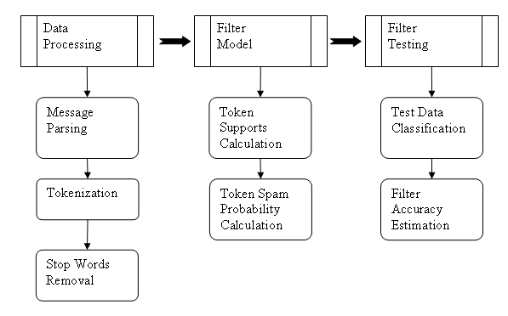
Figure 7: Email Filtration Process

Filtration is a special case of classification in that the process of filtration is similar to that of classification. Input to filtration module is a message and output from it is a probability value with which the message can be classified as spam. The filtration process, just like classification, is: build a filter model, train it from a training set of emails, test using a training set, and use that model to filter other incoming emails. Though, the process steps are similar in nature to those of classification, their operation are different in nature. In fact difference is inherent to the problem of classification and filtration: filtration has to deal specially with content of the message and some headers. Some headers carry more information for filtration whereas none for classification and some items appear identical for classification for filtration which is treated differently in filtration. Filtration has following modules:

Data Processing
This module receives an email message and outputs a set of tokens. It has following components:
- Message parsing: Input email in the form of plain text is parsed to separate headers and body part. It uses RFC 2822 format to parse the email text.

- Tokenization: Each email header or body content is tokenized. All the space characters (space, new line, and tab) are considered as token separator. Special characters like: @, $, .,!, are considered part of the token. Also, tokens are not stemmed, since different form of a word carry different value for spam probability. Header name is appended at the beginning of token to distinguish the same token occurring in different headers.

- Stop words removal: This process is identical to that of classification.

Filter Model
Filter model is a set of tokens, each token mapped to probability of that token to be in spam. The input to this sub module is a set of messages processed to give a set of tokens and output is the filter model. This module has following components:
- Token Supports Calculation: Token supports are two maps: one mapping a token to number of occurrence of that in spam messages and the other mapping to that occurrence in ham messages. Outputs of this sub module are these two large maps.
- Token spam probability calculation: Token supports are used to calculate probability of each token to be in spam message. Each token is then mapped to corresponding probability.

Testing filter
Incoming message is processed to obtain the frequent tokens. For each token, spam probability is obtained from the model. Using this individual probabilities, combined probability is calculated which is the probability of that message being spam.

Email Summarization
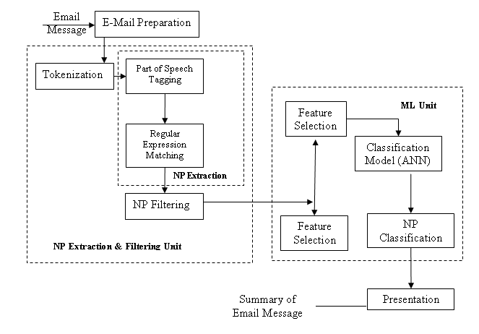
Figure 8: Email Summarization Process

The input to the summarization module is a single email message. The architecture of this module as presented in Figure above consists of four distinct functional components email preprocessing, Noun Phrase extraction and Filtering unit, Machine Learning unit and presentation. Machine Learning unit consists of a feature selection module and a classifier to train statistical features of noun phrases in an email summary. This module requires a training set consisting statistical features of important sentences in an email.

Email Preprocessing
This module processes the incoming email message and analyses the header of it. Unwanted headers and signature blocks are removed and presented to the next module. Email Thread is processed so as to form a single email message.

Noun Phrase Extraction and Filtering
This module performs email processing for extraction and filtering of simple NP candidates and is done by following components:

  - Text Tokenization: This component tokenizes the preprocessed email.
  - Noun Phrase Extraction
    - Part of speech tagging for each token
    - Regular expression matching to find noun phrase in an email
  - NP Filtering to filter unwanted and mostly appearing Noun Phrases

Machine Learning Unit
The first component of the Machine Learning unit is the feature selection module to compute NP vectors. In the training phase, a model for identifying salient simple NPs is created. The training data consist of a list of feature vectors already classified as salient/non-salient by the user. Thus we rely on user relevance judgments to train the ML unit. In the extraction phase this unit will classify relevant NPs using the model generated during training.

Presentation
This module presents the summary of an email to the user. This module extracts the sentences that consist of salient noun phrases that are resulted from the classifier. This module is related to the UI part of the system.

System Development

Methodology
System Development Methodology is a general term applied to a variety of structured, organized processes for developing information technology and embedded software systems. It has undergone series of changes and not all methodology is applicable to all software development process. Our project, CORVID, is a research oriented project, therefore traditional approaches like Waterfall model is not suited for the development process.
We have followed agile software methodology, but we have not strictly adapted to the principles of agile method. Since agile is best suited for dynamic and risky project, XP (extreme programming) methodology has been best suited for our environment.

Tools & Environment
The development tools we have used are:

Visual Studio 2005
Visual Studio is an integrated environment for developing applications for the Windows OS. We have created DLL (dynamic link library) components which are packaged into the mail extension package.

Gecko SDK
The Gecko SDK is a set of XPIDL files, headers and tools to develop XPCOM components which can then in turn e.g. be accessed from XUL using JavaScript. We have created XPCOM components which are packaged into the main extension package.

Project Status

Completed Tasks

Our project consists of the three modules Filtration, Classification and Summarization. These modules are the core part of our project and its integration into thunderbird is the final stage of the project. The current status of the project can be seen in the bar chart below. The development of all the modules is complete and we are in the integration stage of the project.
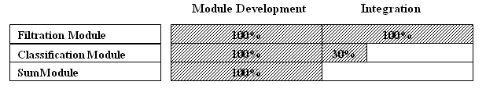
Figure 9: Overall Project Status

Remaining Tasks

Besides integration of the above modules in thunderbird, the tasks remaining for enhancement of the project are as follow:
- Enhancement in performance (in time) of the above modules.
- The training corpus needs to be expanded to yield better results.
- The extension needs to be tested on different platforms.

Concluding Words

We have implemented sound and complete algorithms to achieve effective classification, summarization and filtering of the emails. The project so far has been successful and is scheduled to meet its deadline. We have dedicated our time and effort for the project and we are confident in full functioning of the project. Although we have seen many ups and downs in the development process, we are likely to overcome them and produce good results. Since our project is a research oriented project, we have seen unlikely results and are working hard to deliver reliable outputs to the user.
We would like to thank our supervisors for giving us reliable guidance in the project development and all our friends who have supported us.

References

- Ruth Bergman, Martin Griss, Carl Staelin, A Personal Email Assistant, HP Laboratories Palo Alto, HPL-2002-236, August 22nd , 2002
- John Graham-Cumming, Three years of Spam Mutation. In the Proceedings of The Spammer’s Compendium, January 2003
- Marti Hearst, Applied Natural Language Processing, In the Proceedings of Presentation on Natural Language Processing for Email, October 2004
- Jason D. M. Rennie, ifile: An Application of Machine Learning to Email Filtering. At the Artificial Intelligence Lab Massachusetts Institute of Technology, Cambridge.
- Xavier Carreas and Llujes Marquez, Boosting Trees for Anti-Spam Filtering, TALP Research Center, September 2001.
- Victor R. Carvalho & William W. Cohen, Learning to Extract Signature and Reply Lines from Email, in CEAS 2004
- Mehran Sahami, Susan Dumais, David Heckerman and Eric Horvitz, A Bayesian Approach to Filtering Junk Mail. In the Computer Science Department Stanford University.
- Gary Boone, Concept Features in Re-Agent, an Intelligent Email Agent, Georgia Institute of Technology.
- Richard Cole, Gerd Stumme, CEM- A Conceptual Email Manager. School of Information Technology, Griffith University Gold Coast Campus
- Giuseppe Manco, Elio Masciari, Massimo Ruffolo, Andrea Tagarelli, Towards An Adaptive Mail Classifier
- Julia Itskevitch, Belorussian, Automatic Email Classification using Association Rules. State Polytechnic Academy, 1997
- Shaun Abushar and Naoki Hirata, Filtering with Intelligent Software Agents
- Smaranda Muresan, Evelyne Tzoukermann, Judith L. Klavans, Combining Linguistic and Machine Learning Techniques for Email Summarization
- Xiaodong Zhou, Email Mining and Summarization

Appendices

Sample Output

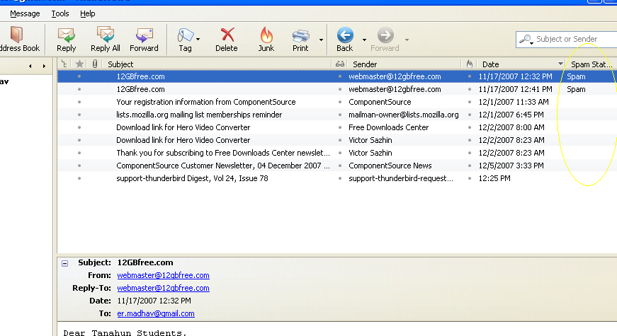
Figure 10: Snapshot showing CORVID email filtering in Thunderbird

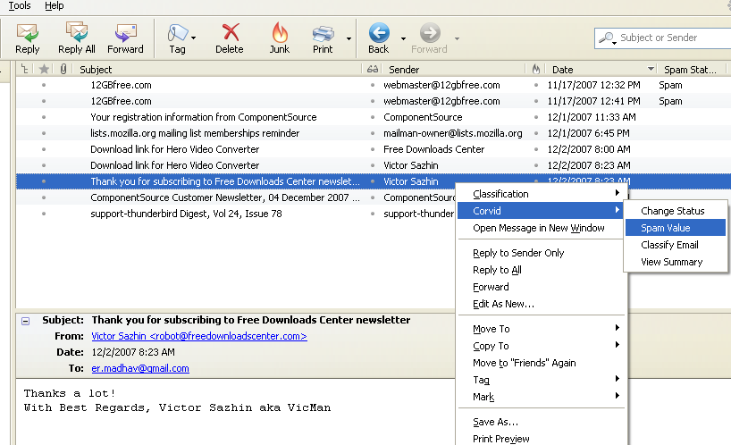
Figure 11: Snapshot showing CORVID features
Contact List
Name | Email | Contact No.
Lekhnath Bhusal | lnbhusal@hotmail.com | 9841679323
Madhav Sigdel | madhav_sigdel@hotmail.com | 9841542563
Mahesh Raj Regmee | mahesh_rg@hotmail.com | 9841611806
Prajwal Shrestha | prajwalsh@gmail.com | 9841303981

Thank You

